ANTENNA GAIN MEASUREMENT

Objective: To measure the gain of wave guide horn.

List of Equipment:
- Microwave source with square wave modulation
- Isolator
- Variable attenuator
- Two identical waveguide horns
- Antenna test bench
- Tunable Detector
- VSWR meter

Theory:
The ability of an antenna to concentrate the radiated power in a given direction, or conversely to absorb effectively incident power form that direction, is specified variously in terms of its gain, power gain, directive gain, or directivity. The precise significance of each of these terms is most readily stated by first defining a quantity known as radiation intensity.
Radiation intensity is defined a power radiated per unit solid angle. Thus,
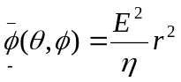watts per unit solid angle (1)
where 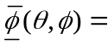radiation intensity in the direction 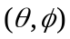
E = far electric field intensity
= intrinsic impedance of the medium
r = distance form the antenna
The average radiation intensity is defined as
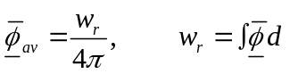 (2)
where 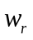is the total power radiated. 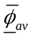 may be considered to be the radiation intensity of an isotropic radiator, radiating same total power. The directive gain,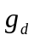, in a given direction is defined as the ratio or radiation intensity in that direction to the average radiation intensity, i.e.
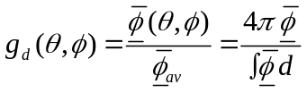 (3)
Often the directive gain is expressed in decibels as
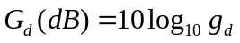 (4)
Clearly, 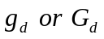 is a function of direction. Maximum directive gain is called directivity. In practice, it is power gain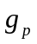, defined as
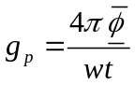 (5)
which comes into play. Here, 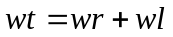is the total power including losses, fed to the antenna.
Although these definitions have been framed by considering a transmitting antenna, these are applicable to receiving antennas too. Of course, the gain thus defines can be realized on a receiving antenna only when it is properly matched and an approximately polarized field is present. For receiving antennas, one defines the effective area A as
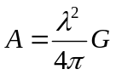 (6)
where G is for antennas with an efficiency of 100%, and G is for lossy antennas.

Power density at a distance R from a point source fed with a power 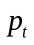is
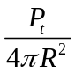 (7)
If however, the radiator is an antenna with gain G, the power density increases to
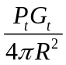 (8)
If an antenna with gain Gz is used to receive the signal, its effective aperture is
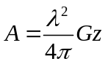
and the power received Pr is given by
Pr = power density × effective aperture
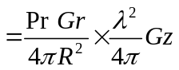
= 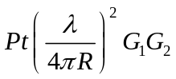
If 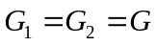
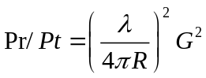
or 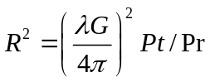 (9)
Measuring 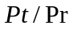by interesting an attenuator to maintain constant power detected with and without antenna system allows 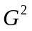to be calculated. As several readings must be taken, it is best to plot against R² and evaluate G from the slope of the graph.
Theoretical calculation of gain of waveguide horn antennas is given in [3] and [4]. For a well constructed horn, measured power gain values are quire close to the calculated values.

Procedure:
Test Antenna Receiving
Antenna
Microwave Source with square wave modulation

Isolator

Variable Attenuator
Tunable detector

Waveguide

VSWR meter

Fig 1. Experimental arrangement for Gain measurement

- Calculate 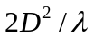where D is the largest dimension of the aperture of the horn and is the free space wavelength corresponding to 10 GHz. During the experiment, the horns should not get any closer to each other than this distance.
- Set up apparatus as shown in fig.1. Set the source at 10 GHz, using square-wave modulation if necessary and tune the detector. Set the calibrated attenuator for O dB attenuation. Carefully align the antennas, by moving the receiving antenna horizontally as well as vertically, for maximum meter reading. Adjust the meter gain for half-scale deflection. Record the distance between the horns.
- Remove the waveguide horns and attach the tuned detector directly to the waveguide or twist preceding the transmitting horn. Insert attenuation through calibrated attenuator to restore half scale deflection on the meter. Record this attenuator setting.
- Connect the horns again and increase their separation by 20 cms. Reduce the attenuation to zero. Carry out alignment for maximum output and meter gain adjustment for half-scale deflection. Determine the attenuation (in dB) required to reproduce this deflection. Determine the attenuation (in dB) required to reproduce this deflection when detector is attached directly to the wave guide or twist. Record this attention and the corresponding distance between the horns.
- Repeat step 4 a few times and tabulate the readings. If N is the number of decibels of attenuation, the ration in eq. (9) can be calculated as
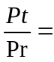 Anti 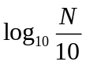
- Plot a graph between the square of the distance between horns 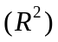along y-axis and the power ratio along x-axis.
- Calculating the slope 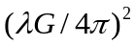form the graph. Knowing, calculate G.
- Compare the theoretical and measured gain values.

Discussions:
- What do you understand by antenna gain?
- How do you know that antenna is tuned at the correct frequency?
- Why the distance between both the horns should be more than?
- What will happen if both antennas are not aligned horizontally or vertically?

References:
- E.C. Jordan and K.G.Balmain, ‘Electromagnetic wave Radiating Systems’ 1968.
- R.E. Collin, ‘Antennas and Radio Wave Propagation’, 1985.
- C.A. Balanis, ‘Antenna Theory: Analysis and Design, 1982.
- A.W. Cross, ‘Experimental Microwaves’, 1977.

